Ending At Fault Law Enforcement Crashes
Syllabus
  - 2025

Instructor information
Instructor | Email | Website
Garry L. Parker | gpa@austin.rr.com | www.garryparkerandassociates.com

Seminar Content

Description
Law Enforcement has experienced more danger in the last four years than I can remember in my forty-five years of service. One danger has remained constant, emergency vehicle crashes. This danger is totally preventable.
Ending at fault law enforcement crashes will expose in detail crashes that took the lives of emergency vehicle operators and civilians exposed to dangerous situations.
Attendees will evaluate performance from dash cam videos and news reports of these cases.
Finally, attendees will discuss how to eliminate these events.

Expectations and goals
Attendees will realize emergency vehicle crashes are preventable.
Attendees will examine their personal behavior to reduce danger to themselves and liability to the agency.
Attendees will recognize if dangerous driving behavior continues, it is not if, but when it happens.

Course schedule
Hour | Topic | Content | Delivery
1 | Introduction | Failures in training | Lecture, Q&A
2 | Environment | Safety outside of the vehicle | Lecture, Practical application vehicle and officer positioning
3 | Driver Training | Case Law, State Statute, Due Regard | Lecture, Q&A
4&5 | Routine Patrol | Most dangerous activity, but least discussed, 5 critical mistakes officers make | Lecture, Q&A
5&6 | Decisions and Consequences | Questionable tactics will continue until tragedy strikes. | Attendees will evaluate decisions made and actions to prevent tragedies in their jurisdiction.
7 | Focus | Prevention requires a mindset of focusing on the task at hand. You cannot be of assistance if you do not arrive. Response video from three common calls that injure or kill officers and civilians. | Lecture, Q&A, Attendee discussions
8 | Cop Shock | Discussion of PTSD and identification of mental health resources for police officer.  Officers realize many officers struggle and help is available. | Lecture, Q&A, Tools provided by instructor to retain lessons from the class.

Additional information and resources

Course and Instructor Assessment
Each student will complete a 10-question assessment to ensure information was delivered and received. A passing score of 75% must be achieved.
Each student will complete an instructor evaluation at the end of the seminar.

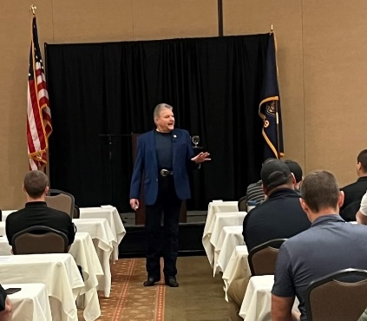
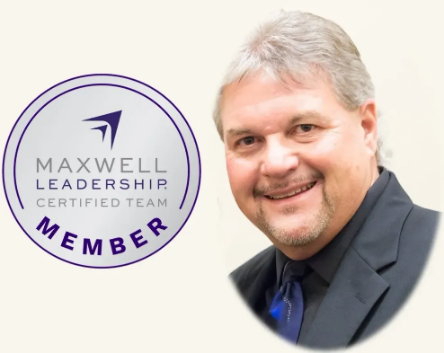
Garry L. Parker
Short Biographical Sketch

Garry Parker is certified as a speaker, trainer and coach through the Maxwell Leadership Team, the International Speakers Network, and the Texas Commission on Law Enforcement.
Garry is nationally recognized as a trainer and consultant in traffic safety, crash prevention, law enforcement tasks and emergency vehicle operation.
Garry is a motivational speaker, trainer and coach on communication and leadership.
Garry has been recognized for excellence in program development and presentation and has served as keynote speaker for many conferences around the country.

