Street Level Leadership
Syllabus

Instructor information
Instructor | Email | Website
Garry L. Parker | gpa@austin.rr.com | www.garryparkerandassociates.com

Seminar Content

Description
Leadership has become a buzz word in the law enforcement profession. With so much talk, why is there still a lack from street police officers to those in charge of the agency? Leadership should focus on making each officer better today than yesterday. This is accomplished by starting the process early in the career of each officer. Academy training could be described as drinking from a fire hose. The training process does not end with graduation and the field training officer program.
Street Level Leadership was designed for, but not limited to, officers with 3-5 years of street experience, F.T. O’s and first line supervisors.

Expectations and goals
Attendees will understand why many topics thought to be irrelevant play a huge role in street patrol.
Attendees will recognize ethics, diversity and communication are essential in the success or failure of a police officer.
Attendees will examine their personal behavior to identify areas they need to become more proficient.

Course schedule
Hour | Topic | Content | Delivery
1 | Introduction | The current state of the profession and why leadership is essential | Lecture, Q&A
2&3 | Ethics, Ethos, Diversity | A deep dive into ethical and moral disengagement. Why understanding diversity will help to improve relations on the street and in the agency | Lecture, Q&A
4 | Communication | 90% of law enforcement is communication, but communication is never taught. Learning how we communicate, and relate to those we work with and those we serve | Lecture, Q&A  Personality assessment designed to identify communication traits of each attendee.
5&6 | Five levels of leadership | It is impossible to lead anyone if you can’t lead yourself. Personal, Production, Positional, Permission, People development | Lecture, Q&A
7 | Cop Shock | Discussion of PTSD and identification of mental health resources for police officer.  Officers realize many officers struggle and help is available. | Lecture, Q&A,  Attendee discussions
8 | Motivation for tomorrow | Wrap up of the day. Encouraging each attendee to make leadership a journey, not a destination. | Lecture, Q&A,

Additional information and resources

Course and Instructor Assessment
Each student will complete a 10-question assessment to ensure information was delivered and received. A passing score of 75% must be achieved.
Each student will complete an instructor evaluation at the end of the seminar.

About the Instructor
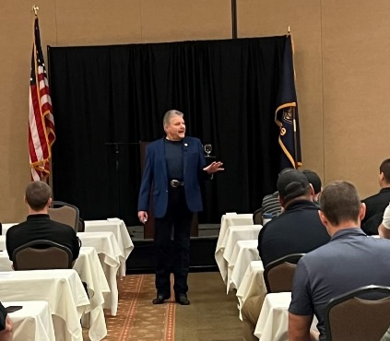
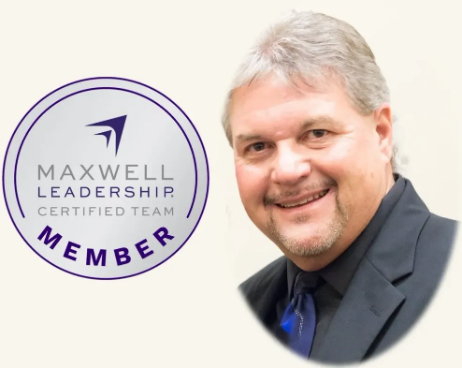
Garry L. Parker
Short Biographical Sketch

Garry Parker is certified as a speaker, trainer and coach through the Maxwell Leadership Team, the International Speakers Network, and the Texas Commission on Law Enforcement.
Garry is nationally recognized as a trainer and consultant in traffic safety, crash prevention, law enforcement tasks and emergency vehicle operation.
Garry is a motivational speaker, trainer and coach on communication and leadership.
Garry has been recognized for excellence in program development and presentation and has served as keynote speaker for many conferences around the country.

